Project 13: Special Characters

Objectives:
At the end of this project, you will be able to:
- Create a table with alternating row colors.
- Use special characters in web pages.

Instructions:

- Use the Special Characters reference sheet provided by your teacher for this project.
- Create a new folder called "Special Characters".
- Create a new XHTML document and save it as "index.html" in this new folder.
- Set the title to be "Special Characters".
- Using an internal CSS style sheet, apply a 20px Arial font to the entire page by styling the <body> element directly.
- Create the following table:
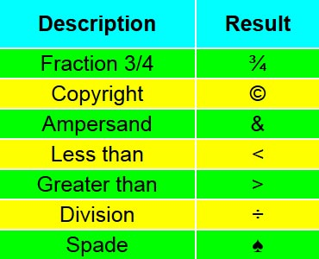
- After the table, add a paragraph that reads: ¿Te gustaría aprender a hablar español?
(Notice there are three special characters in this sentence.)
- Requirement #1: The table is 300px wide and the colors used are aqua, lime, and yellow.
- Requirement #2: The first row is taller than the later rows.
- Requirement #3: Create two separate CSS classes for the alternating rows.

Rubric 13: Special Characters

Name: ____________________________

Component | Possible Points | Score
The font and font size are applied directly to the <body> element. | 2
The first row of the table uses <th> elements and has the background color and padding applied. | 3
Two separate classes were created for the table rows and applied alternately to show the different color backgrounds. | 4
The table has the correct description texts and special characters. | 5
The sentence in Spanish uses the three special characters correctly. | 4
All elements were nested correctly and there were no other XHTML errors. | 2
Total Score | 20

